A PROJECT REPORT
ON

Go Home

Submitted by
Desai Krisha P(196150316008) Modi Hetvi M(196150316034)

In partial fulfilment for the award of the degree of
DIPLOMA IN ENGINEERING
in
Information Technology



Government Polytechnic for Girls, Surat

Gujarat Technological University, Ahmedabad

March 2022

Athwagate, Surat-395001

CERTIFICATE

This is to certify that the project report, submitted along with the project entitled Go Home has been carried out by Desai Krisha P(196150316008), Modi Hetvi M(196150316034) under my guidance in partial fulfilment for the degree of Diploma in Information Technology 6th Semester of Gujarat Technological University, Ahmedabad during the academic year 2021-22. These students have successfully completed project activity under my guidance.

External Examiner:


Mr. Pragnesh Patel
Guide, Lecturer IT Department GPG, Surat
Ms. Jigna J. Desai
Head
IT Department GPG, Surat

We are greatly thankful to Government Polytechnic for Girls Surat for allowing us to develop this project. Then our humble thanks to all professors and staff members of our college for co-operating and keeping interested extended by them throughout our diploma engineering course. This is the base that they have built, which sustains such a good job.

We deploy our gratitude for project guidance to MRS. JIGNA DESAI (H.O.D), MR. PRAGNESH PATEL and other faculty members for their kind help throughout this project which ensures no words to express our gratitude to our guides and other faculties without their moral support and encouragement.

We take this opportunity to thank all lecturers who have directly or indirectly helped in our project. We pay our respect and love to our parents and all other family members and friends for their love and encouragement throughout our careers. Last but not least we express our thanks to our friends for their co-operation and support.

Krisha Desai(196150316008) Hetvi Modi(196150316034)

ABSTRACT

This work demonstrates a simple home automation system that allows the user to control home appliances through Wi-Fi/Bluetooth. Lights and fans are the appliances that can be used in this system. In this system, the appliances' controlling and monitoring can be performed by using a smartphone-based Android Application. The concept behind this is to manage home devices with voice. There are several devices accessible to try and do that on the market. Build your assistant which will do the work for you. The idea behind this can be to control home devices with voice. There is a unit several devices out there on the market to try and do that. However, creating your own is awful. Build an assistant that may do the work for you. Simply your assistant needs voice commands. Consistent with voice command home appliances can switch ON/OFF.

Table of Contents III
Chapter 1: Introduction 1
  - Project Summary 1
  - Purpose 1
  - Scope 1
  - Report Outline 2
Chapter 2: Literature Review 3
  - Existing System 3
  - Problems in existing system 3
  - Problem Solution: 3
Chapter 3: Project Management 4
  - Project Planning and scheduling 4
    - Project Development Approach 4
    - Project Plan 6
    - Schedule Representation 7
Chapter 4: System Requirements Specification 8
  - functional Requirement 8
  - Non-functional requirements 9
  - Hardware and Software Requirement 9
Chapter 5: System Analysis 10
  - Feasibility Study 10
    - Technical Feasibility 10
    - Economical Feasibility 10
    - Operational Feasibility 10
  - Function of System 11
    - Use Case Diagram 11
  - Data Modeling 12
    - Class Diagram 12
    - E-R Diagram 13

Functional and Behavioral Modeling 15
5.3.4 Data Flow Diagram 15
Chapter 6: System Design 17
6.1 Database Schema Design 17
Chapter 7: Testing 18
Chapter 8: Implementation 21
Chapter 9: Conclusion and Future Work 36

Figure 1: Prototype Model 5
Figure 2 : Use Case Diagram 11
Figure 3 : Class diagram 12
Figure 4 : E-R Diagram 13
Figure 5: Activity Diagram 14
Figure 6 : DFD level 0 15
Figure 7 : DFD level 1 16
Figure 8 : LED connection 21
Figure 9 : LCD connection 21
Figure 10 : Shouldering 22
Figure 11 : Bulb holder with bulb 22
Figure 12 : Switch Connection on breadboard 23
Figure 13 : Node MCU 23
Figure 14 : One Channel Relay Circuit 24
Figure 15 : Circuit 24
Figure 16 : Circuit(Manually turning on light via switch) 25
Figure 17 : Circuit(Both bulb high) 25
Figure 18 : Creating Applet 26
Figure 19 : Creating a Trigger 26
Figure 20 : Creating a simple phrase to turn on light 27
Figure 21 : If this, then that 27
Figure 22 : We need to select webhooks service to make web request 28
Figure 23 : Creating a web request to turn on light 28
Figure 24 : If this, then that 29
Figure 25 : Creating a simple phrase to turn off light 29
Figure 26 : Creating a web request to turn off light 30
Figure 27 : Creating a simple phrase to turn on fan 30
Figure 28 : Creating a web request to turn on fan 31
Figure 29 : Creating a simple phrase to turn off fan 31
Figure 30 : Creating a web request to turn off fan 32
Figure 31 : Google Assistant (turning on light) 32
Figure 32 : Google Assistant (turning off light) 33
Figure 33 : Google Assistant (turning on fan) 33
Figure 34 : Google Assistant (turning off fan) 34
Figure 35 : Light ON via Blynk IoT application 34
Figure 36 : Light ON/OFF via Blynk IoT application 35

Table 1: Project plan 6
Table 2: Gantt Chart 7
Table 3 : User module 8
Table 4 : User Data dictionary 17
Table 5: Appliance Data dictionary 17
Table 6: Mobile Data dictionary 17
Table 7 : Test Case 20

Chapter 1: Introduction

Project Summary
The main intention of this project is to design a home automation system using an Arduino board with Bluetooth/Wi-Fi technology and to control it remotely by an android application on a smartphone. The proposed system uses a Bluetooth/Wi-Fi Module, which is interfaced with the Arduino board at the end of the receiver. At the transmitter end, there will be a google assistant which uses voice commands to control appliances. Also, there will be a built-in button to control the appliance. When the user provides the voice command “Turn On Light”, the light2 will be turned On.

Purpose

Previously, it was a tedious job for old age people to turn on-off lights, fans, or any other electrical appliances. Also, it was costly to buy a switchboard, to repair the switch. So, we are here with a solution by making an android application name “GO Home”.

Use “GO HOME” to make your home a more comfortable, livable space. The proposed system eliminates the complication of wiring in the case of wired automation. The operating range is more than the Bluetooth. The existing system does not allow remote monitoring and controlling of appliances. But wherein the proposed system uses the Wi-Fi-based home automation system it allows monitoring and controlling the appliances. The home automation of the existing system in the 1990s, the people in every home has electronic devices which are controlled manually but in our proposed system we are controlling electronic appliances through remotely. The IoT application has become this popular in this 21st century is due to the dominant use of the internet, the evolution of smartphone technology, and raised standard of mobile communication.

The purpose of the system is to stimulate smart, understandable, and accessible solutions and services for the personal environment. Make it suitable for disabled and elderly people.

Scope

Home automation is the wireless and remote control of different aspects of a living space like lighting, temperature, security, entertainment, etc. It performs with the help of connected smart devices and appliances that use communication technology like WIFI, Node MCU, Arduino, and Ethernet, to share data and facilitate the efficient management of power consumption. It has advantages like:

Voice Over: We can provide a Voice command to On/Off the appliance.

Low Cost: We are providing a low-cost application as compared to the devices available in the market like Alexa, Google home.

Report Outline

The next chapters will cover the following contents:

Chapter 2: Literature view

It shows the contrast between the existing system and the system we have made. It shows us why we need to bring the same system which is already on the market. It shows us the drawbacks of the existing system and how will we overcome that drawback OR the advantages of our system.

Chapter 3: Project Management

Project Management includes Project planning, project scheduling, Project Development approach, Project plan, and Schedule representation. The Project Development approach tells us about which development model we are using in our system. The project plan represents the time duration in which different tasks of the project have been accomplished. Schedule representation shows the graphical representation of the project plan.

Chapter 4: System Requirement Specification

In this chapter, we will discuss Functional and Non-Functional Requirements. Also, we will discuss the Hardware and Software requirements of our project.

Chapter 5: System Analysis

In this chapter, we will discuss feasibility study(i.e, Technical feasibility, Economical feasibility, Operational feasibility). Also, we will discuss the Function of our system and Data modeling.

Chapter 6: System Design

In System design, we will discuss the Database schema design that shows the table of data dictionaries of our system.

Chapter 7 : Conclusion & Future work

In this, we will write a small note of our project conclusion which will include what we have done, how we have done it, etc. Also, we will give references for our future work.

Chapter 2: Literature Review

  - Existing System

Presently, we find problems in the existing system. It is too difficult for older people to get up and power on the lights and fans, as they are having many physical problems. In the market there are many homes automation systems like Echo Dot, Google Home, and Qubo, the only problem is they occupy space. The other reason is they can’t operate this device when they are outside of the home. Like if they want to turn on the light while reaching the home so they don’t need to worry about what’s hiding in the shadow and they can’t control the temperature of their home. There is also an application available in the market but there are some drawbacks regarding them.

  - Problems in the existing system

Today, it has never been easier or more affordable to purchase and install smart devices and home automation systems. In echo dot, it is not able to understand our commands 70-80%. Secondly, it has to plug in all the time and the same for google home also which consumes lots of energy. In addition, there is base sound is also low. In applications like Smart Things, Mi control, and Philipps Hue they have some or the other problem. In Mi control there is no option for ceiling light which is an important part of our home, coming to Smart Things it only connects to Samsung products, so only for that no one is going to purchase that company appliance, and in Philipps Hue, we can’t even login in their application without control box which costlier and everyone can afford it.

  - Problem Solution:

While people are pursuing the ever-growing high quality of their lives today. This leads to more and more facilities and home appliances being poured into their buildings. How to control and manage these versatile facilities and appliances in a house?

Usually, conventional wall switches are located in different corners of a house and, thus necessitate the need for manual operations like pressing to turn the loads on or off. It becomes very difficult for the elderly or physically handicapped people to operate them. So, we provide a feature of voice-over so they can conveniently operate it by their phone. We use an android application for the voice-over, so it doesn’t occupy space and also saves lots of money and middle-class people can also afford it. We also provide all company appliances to connect easily.

Chapter 3: Project Management

  - Project Planning and scheduling

Project Development Approach

Prototype Model

The prototype model requires that before carrying out the development of actual software, a working prototype of the system should be built. A prototype is a toy implementation of the system. A prototype usually turns out to be a very crude version of the actual system, possibly exhibiting limited functional capabilities, low reliability, and inefficient performance as compared to the actual software. In many instances, the client only has a general view of what is expected from the software product. In such a scenario where there is an absence of detailed information regarding the input to the system, the processing needs, and the output requirement, the prototyping model may be employed.

In this process model, the system is partially implemented before or during the analysis phase thereby allowing the customers to see the product early in the life cycle. The process starts by interviewing the customers and developing the incomplete high-level paper model. This document is used to build the initial prototype supporting only the basic functionality as desired by the customer. Once the customer figures out the problems, the prototype is further refined to eliminate them. The process continues until the user approves the prototype and finds the working model to be satisfactory.

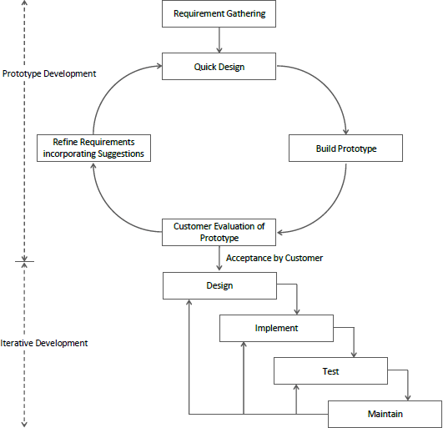

Figure 1: Prototype model

The Prototyping Model should be used when the requirements of the product are not clearly understood or are unstable. It can also be used if requirements are changing quickly. This model can be successfully used for developing user interfaces, high technology software-intensive systems, and systems with complex algorithms and interfaces. It is also a very good choice to demonstrate the technical feasibility of the product.

Why do we use this model for our system?

- The customers get to see the partial product early in the life cycle. This ensures a greater level of customer satisfaction and comfort.

- Missing functionalities can be easily figured out.

- Errors can be detected much earlier thereby saving a lot of effort and cost, besides enhancing the quality of the software.

Project Plan

Date | Action | Month
15/06/21 to 20/06/21 | Find definition, Analyze the definition | June
21/06/21 to 29/06/21 | Abstract Generation, Analysis of system | June
02/07/21 to 16/07/21 | Development approach | July
17/07/21 to 20/07/21 | Work Division | July
22/07/21 to 05/08/21 | Functionalities & characteristics of the system | July/August
10/08/21 to 20/08/21 | Diagrams | August
21/08/21 to 24/08/21 | Design | August
25/08/21 to 30/09/21 | Documentation | August/September
2/10/21 to 15/3/22 | Implementation | October/March
15/3/22 to 30/3/22 | Testing | March

Table 1: project plan

3.1.1 Schedule Representation

Work Task | Jun |  |  | Jul |  |  | Aug |  |  |  | Sep | Oct |  | Nov | Dec | Jan | Feb | Mar
Find definition,
analyse the definition
Abstract generation, analysis of the system.
Development
approach
Work Division
Functionalities and characteristics
of the system
Diagrams
Design
Documentation
Implementation
Testing

Table 2 : Gantt Chart

Chapter 4: System Requirements Specification
  - Functional Requirement

Functional requirement denotes the function that a developer must build into the software to achieve use- case. It describes the relationship between input and output. The functional requirement for Go Home is thus, according to the use-case described below:

    - User Module

FR1: Add/Remove/Update | Input: Users has to give appliance name and its ID to add, they can remove the appliance and  Process: System add/ remove/ update the appliance done by the user.  Output: Display the added, removed, and updated in their phone.
FR2: Light/Fan ON-OFF | Input: Users have to give a value of Fan and AC temperature according to their needs.  Process: It will Modify the value as the user has given.  Output: Display the in the appliance.

Table 3 : User module

  - Non-functional requirements

Efficiency: The standard home automation products that give you active control, some products actively monitor the system and the homeowner with knowledge, insight, and guidance to achieve greater control and energy efficiency. In addition to this, there is a voltage and current measurement control function so, the owner can save energy by letting himself know which appliance uses more electricity.

Security: Tap your finger to turn on the lights when you get home so, no need to worry about what’s hiding in the shadows, or your pathways. Or automate to turn on light when you aren’t home to look like you are to ward off potential robbers.

  - Hardware and Software Requirement

Hardware Requirement(minimum requirement):
- Arduino Uno
- Relay circuit
- Connecting wires
- LED
- Fan
- NodeMCU
- Voltage sensor
- System requirement
  - Processor: 10th Gen i5
  - Installed Memory : 6 GB RAM, 512 GB SSD
  - System type: 64-bit operating system

Software Requirement(minimum requirement)
- Arduino 1.6.9 Compiler
- Blynk IoT
- Google Assistant
- Operating System: Microsoft Windows 10

Chapter 5: System Analysis

Feasibility Study
A feasibility study is one of stage among important four stages of the Software Project Management Process. As the name suggests feasibility study is the feasibility analysis or it is a measure of the software product in terms of how beneficial product development will be for the organization from a practical point of view. A feasibility study is carried out based on many purposes to analyze whether software products will be right in terms of development, implantation, the contribution of the project to the organization, etc.

Technical Feasibility

In Technical Feasibility current resources both hardware software along required technology are analyzed/assessed to develop the project. This technical feasibility study reports whether there exists correct required resources and technologies which will be used for project development. Along with this, the feasibility study also analyses the technical skills and capabilities of the technical team, existing technology can be used or not, maintenance and up-gradation is easy or not for chosen technology, etc.

Economical Feasibility
In the Economic Feasibility study cost and benefit of the project are analyzed. This means under this feasibility study a detailed analysis is carried out what will be the cost of the project for development which includes all required costs for final development like hardware and software resources required, design and development cost and operational cost, and so on. After that, it is analyzed whether the project will be beneficial in terms of finance for the organization or not.

Operational Feasibility
In Operational Feasibility degree of providing service to requirements is analyzed along with how much easy the product will be to operate and maintain after deployment. Along with these other operational scopes are determining the usability of the product, determining suggested solution by the software development team is acceptable or not, etc.

  - Function of System

Use Case Diagram

A use case is initiated by the user with a particular goal in mind and completed successfully when the goal is satisfied. It describes the sequence of interactions between the actor and the system necessary to deliver the service that satisfies the goal.

Use cases are used to a common understanding with the systems end-users and the domain experts. The purpose of the use case diagram is to capture the dynamic aspect of a system. The use cases do not mention any specific algorithm to be used or the internal data representation, internal structure of the software, etc.

The utility of the use case is represented by Ellipses. They along with the associated text description serve as the type of requirement specification of the system and from the core model to which all other models must conform.
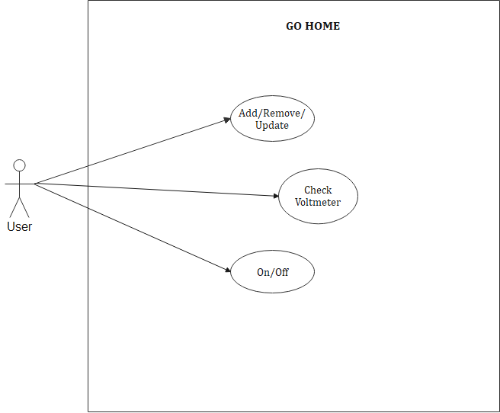

Figure 2: Use case diagram

  - Data Modeling

Class Diagram

Class diagrams are the main building blocks of every object-oriented method. The class diagram can be used to show the classes, relationships, interface, association, and collaboration.

UML is standardized in class diagrams. Since classes are the building block of an application that is based on OOPs, the class diagram has an appropriate structure to represent the classes, inheritance, relationships, and everything that OOPs have in their context.
It describes various kinds of objects and the static relationship between them. The main purpose to use class diagrams are:
- This is the only UML that can appropriately depict various aspects of the OOPs concept.
- Proper design and analysis of applications can be faster and more efficient.
- It is the base for deployment and component diagram.

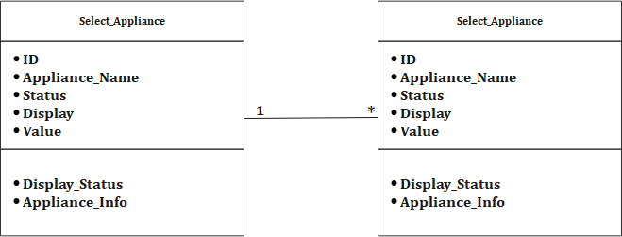

Figure 3 : Class diagram

E-R Diagram

ER diagrams represent a set of real-world entities and the logical relationships among them. This diagram depicts entities, the relationships between them, and the attributes pictorially to provide a high-level description of conceptual data models.

Once an ER diagram is created, the information represented by it is stored in the database. The information depicted in an ER diagram is independent of the type of database and can later be used to create a database of any kind such as a relational database, network database, or hierarchical database.

ER diagram includes data objects and entities, data attributes, relationships, cardinality, and modality.
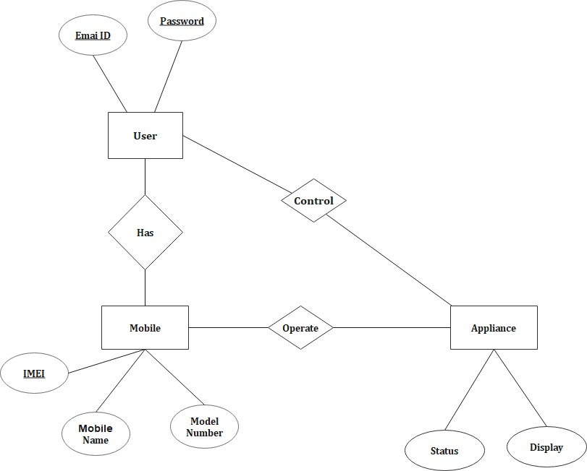
Figure 4 : ER Diagram

Activity diagram

The activity diagram is probably one modeling element that was not present in any of the predecessors of UML.
Activity diagrams are a kind of behavior diagram. UML activity diagrams are somewhat similar to UML state machine diagrams.
The use case is also concerned with the behavior of the system. So activity may be somewhat related to the use case. Activity modeling means to describe sequencing and conditions of actions. Such descriptions commonly are control
flow and object flow models.

Activity diagrams are normally employed in business process modeling. This is carried out during the initial state of requirement analysis and specification. Activity diagrams can be very useful to understand complex processing activities involving many components.

An activity is a state with an internal action and one or more outgoing transitions which automatically follow the termination of the internal activity. If an activity has more than one outgoing transition, then this must be identified through conditions.

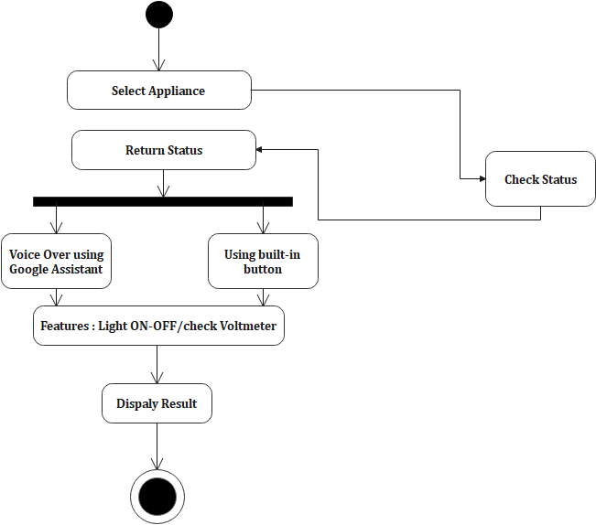

Figure 5: Activity Diagram

Functional and Behavioral Modeling

    - Data Flow Diagram

DFD is the abbreviation for Data Flow Diagram. The flow of data of a system or a process is represented by DFD. It also gives insight into the inputs and outputs of each entity and the process itself. DFD does not have a control flow and no loops or decision rules are present. Specific operations depending on the type of data can be explained by a flowchart. Data Flow diagrams can be represented in several ways. The DFD belongs to structured-analysis modeling tools. Data Flow diagrams are very popular because they help us to visualize the major steps and data involved in software-system processes.

- Level 0

It is also known as the fundamental system model, or context diagram represents the entire software requirement as a single bubble with input and output data denoted by incoming and outgoing arrows. Then the system is decomposed and described as a DFD with multiple bubbles. Parts of the system represented by each of these bubbles are then decomposed and documented as more and more detailed DFDs. This process may be repeated at as many levels as necessary until the program at hand is well understood.

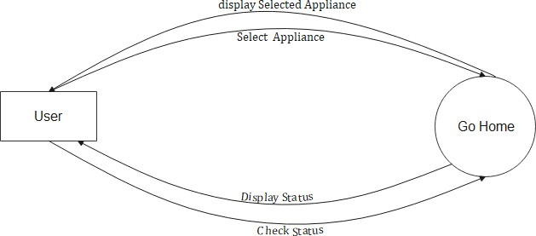

Figure 6 : DFD Level 0

- Level 1

In 1-level DFD, the context diagram is decomposed into multiple bubbles/processes. At this level, we highlight the main functions of the system and break down the high-level process of 0-level DFD into subprocesses.

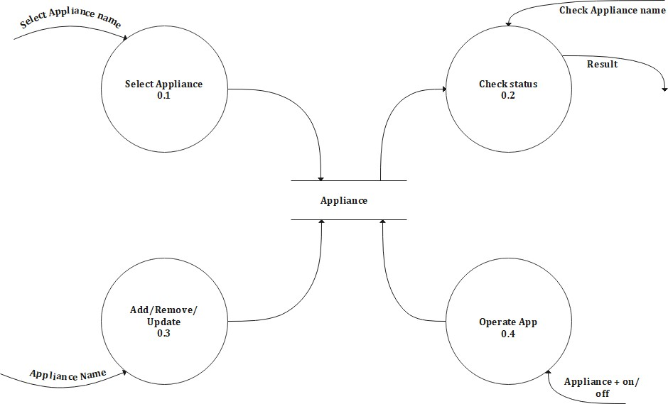

Figure 7 : DFD level 1

Chapter 6: System Design

User

Column Name | Data Type | Constraints | Description
E_ID | Varchar(50) |  | Email ID of the user.
Password | Varchar(20) |  | Password of the user.

Table 3: User Data Dictionary
Appliance

Column Name | Data Type | Constraints | Description
Status | Varchar(50) |  | Shows the status of the appliance.
Display | Varchar(50) |  | Shows the previous status of the appliance.

Table 5: Appliance Data Dictionary
Mobile

Column Name | Constraints | Data Type | Description
IMEI | Primary Key | Int | IMEI number of mobile
Mob_Name |  | Varchar(50) | Mobile Name of the user
Model_No |  | Varchar(50) | Model Number of the mobile

Table 6: Mobile Data Dictionary

Chapter 7: Testing
Software Testing is a method to check whether the actual software product matches expected requirements and to ensure that software product is Defect free. It involves execution of software/system components using manual or automated tools to evaluate one or more properties of interest. The purpose of software testing is to identify errors, gaps or missing requirements in contrast to actual requirements. Some prefer saying Software testing definition as a White Box and Black Box Testing.

Test Case :

Test Case  ID | Components | Description | Input Values | Expected Output | Actual Output | Rema rks
TC01 | NodeMCU | Connect object and let data transfer | Null | Circuit will work | Circuit will work. | Fail
 | NodeMCU | Connect object and let data transfer | Invalid | NodeMCU will turn on | Connection problem | Fail
 | NodeMCU | Connect object and let data transfer | Valid | Valid | Accept | Pass
TC02 | Relay Module | Can be turned on or off | Null | Circuit will work | Circuit will not work. | Fail
 | Relay Module | Can be turned  on or off | Invalid | Relay Module  will turn on. | Connection  problem | Fail
 | Relay Module | Can be turned on or off | Valid | Valid | Accept | Pass
TC03 | Bulb Holder | Supports lamps and connect them to electrical circuits | Null | Circuit will work | Circuit will not work | Fail
 | Bulb Holder | Supports lamps and connect them to electrical  circuits | Invalid | Bulb Holder will get power supply | Connection problem | Fail

 | Bulb Holder | Supports lamps and connect them to electrical circuits | Valid | Valid | Accept | Pass
TC04 | Bulb | To show an electronic device is on or off | Null | Circuit will work | Circuit will not work | Fail
 | Bulb | To show an electronic device is on or  off | Invalid | Bulb will show whether the device is on or  off | Connection problem | Fail
 | Bulb | To show an electronic device is on or off | Valid | Valid | Accept | Pass
TC05 | Switch | Allow connected  device to talk with each other | Null | Circuit will work | Circuit will not work | Fail
 | Switch | Allow connected device to talk  with each other | Invalid | On turning switch on or off, bulb will  respond | Connection problem | Fail
 | Switch | Allow connected device to talk with each other | Valid | Valid | Accept | Pass
TC06 | Voltage Sensor | Provide 24/7  monitoring for voltage data. | Null | Circuit will work | Circuit will not work | Fail
 | Voltage Sensor | Provide 24/7 monitoring for voltage data | Invalid | Will provide measured voltage | Connection problem | Fail
 | Voltage Sensor | Provide 24/7 monitoring for voltage data | Valid | Valid | Accept | Pass
TC07 | Arduino UNO | Write and upload computer code to the physical board. | Null | Circuit will work | Circuit will not work | Fail
 | Arduino UNO | Write and upload computer code to the physical  board. | Invalid | Will help to run the circuit | Connection problem | Fail

 | Ardunio UNO | Write and upload computer code to the physical board | Valid | Valid | Accpet | Pass

Table 7: Test Case

Chapter 8: Implementation

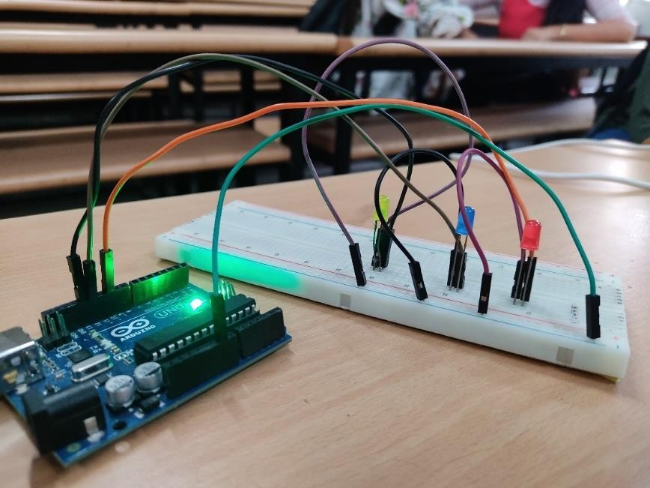
Figure 8: LED connection

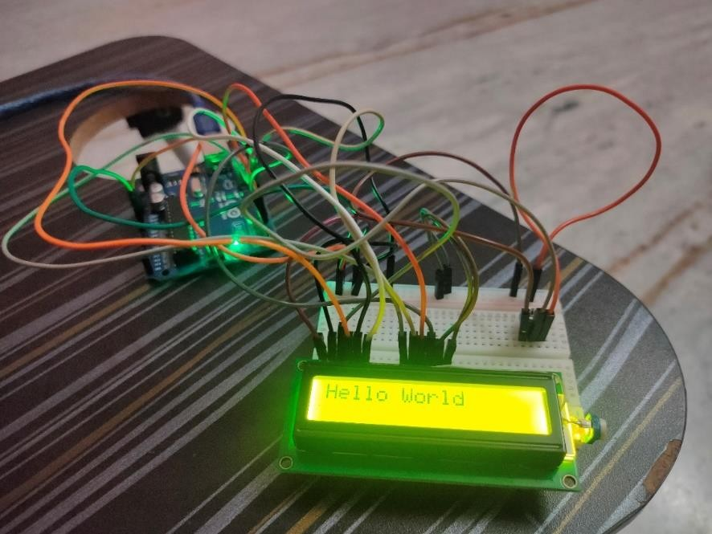
Figure 9: LCD connection

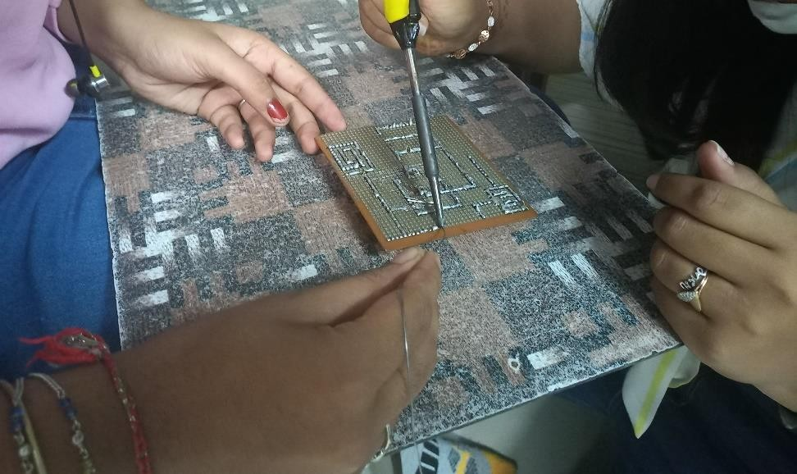

Figure 10: Soldering

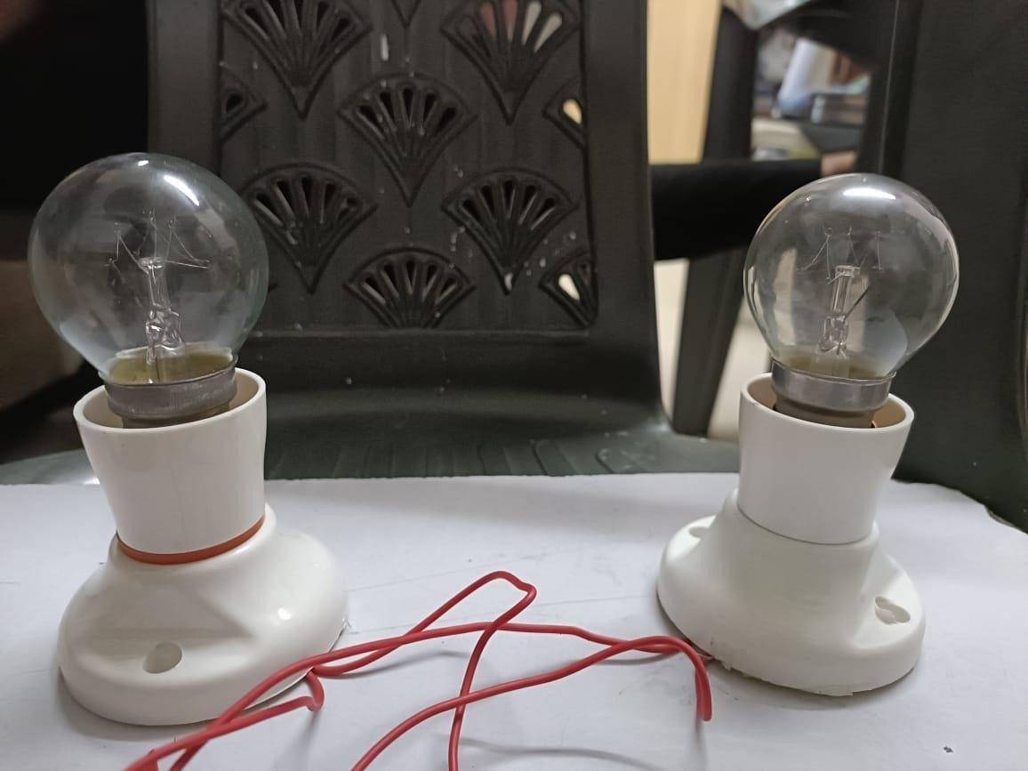
Figure 11: Bulb Holder with Bulb

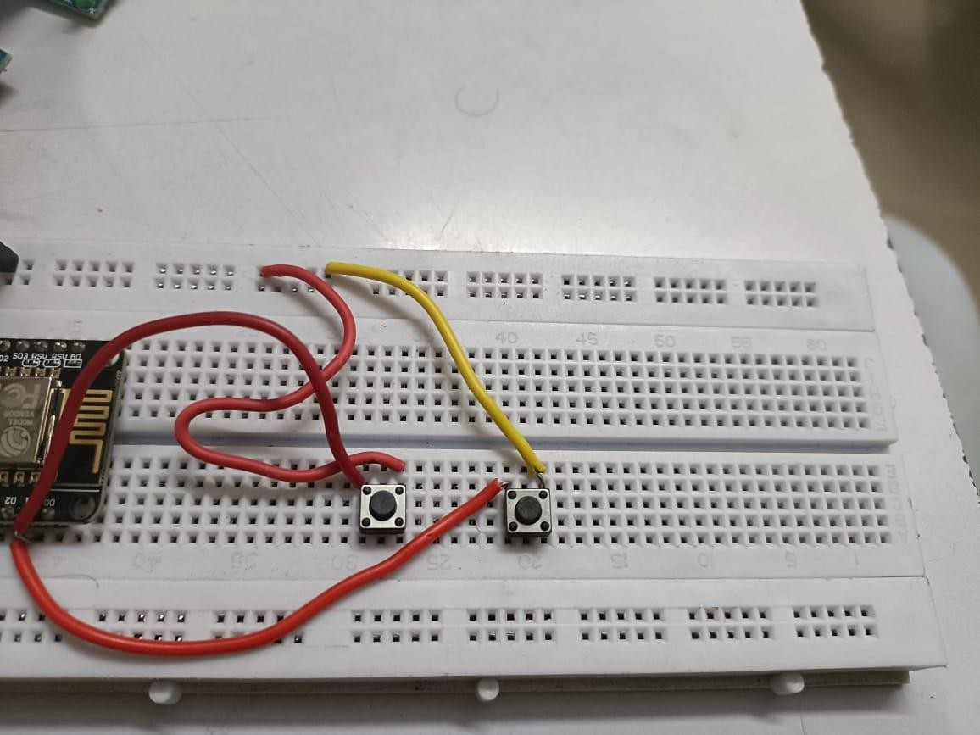

Figure 12: Switch connection on breadboard

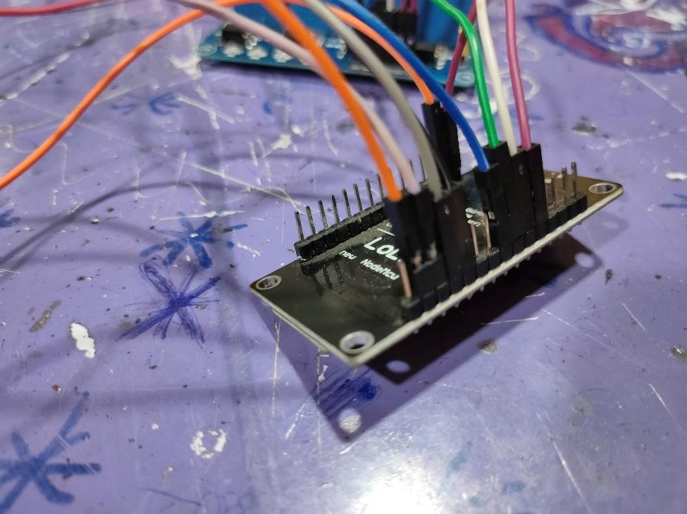

Figure 13: Node MCU

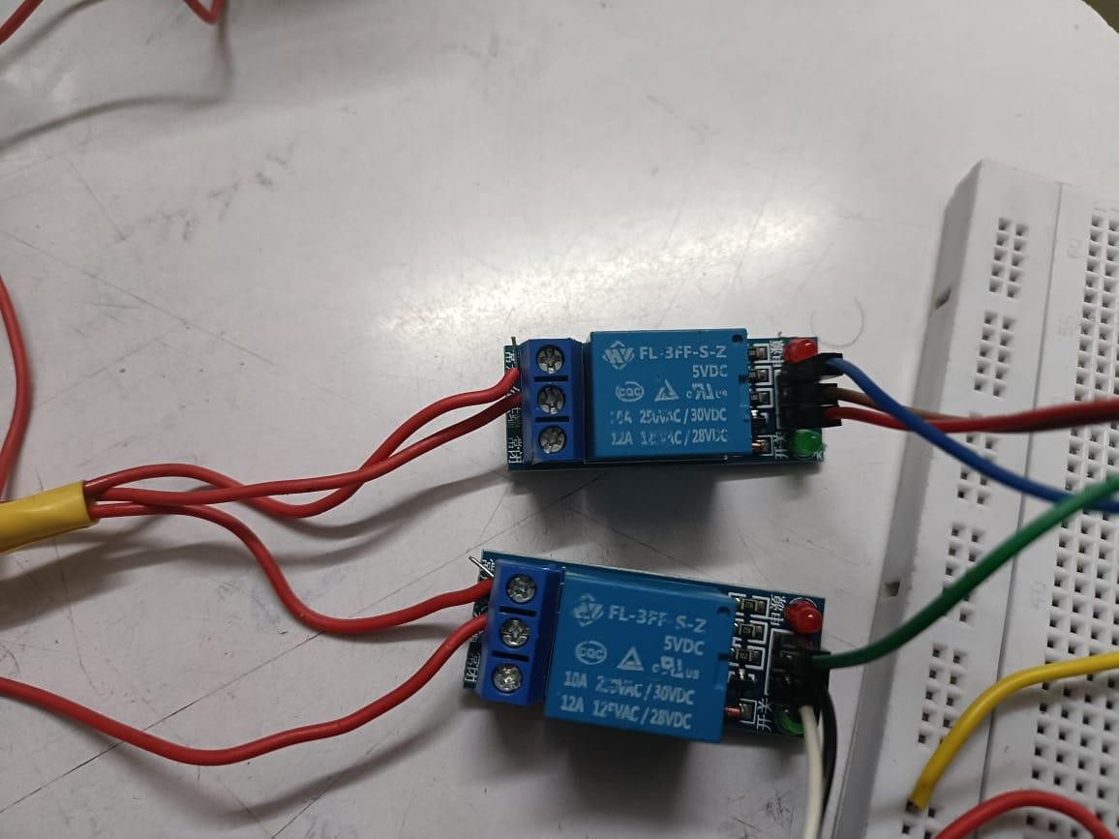

Figure 14: One Channel Relay Circuit

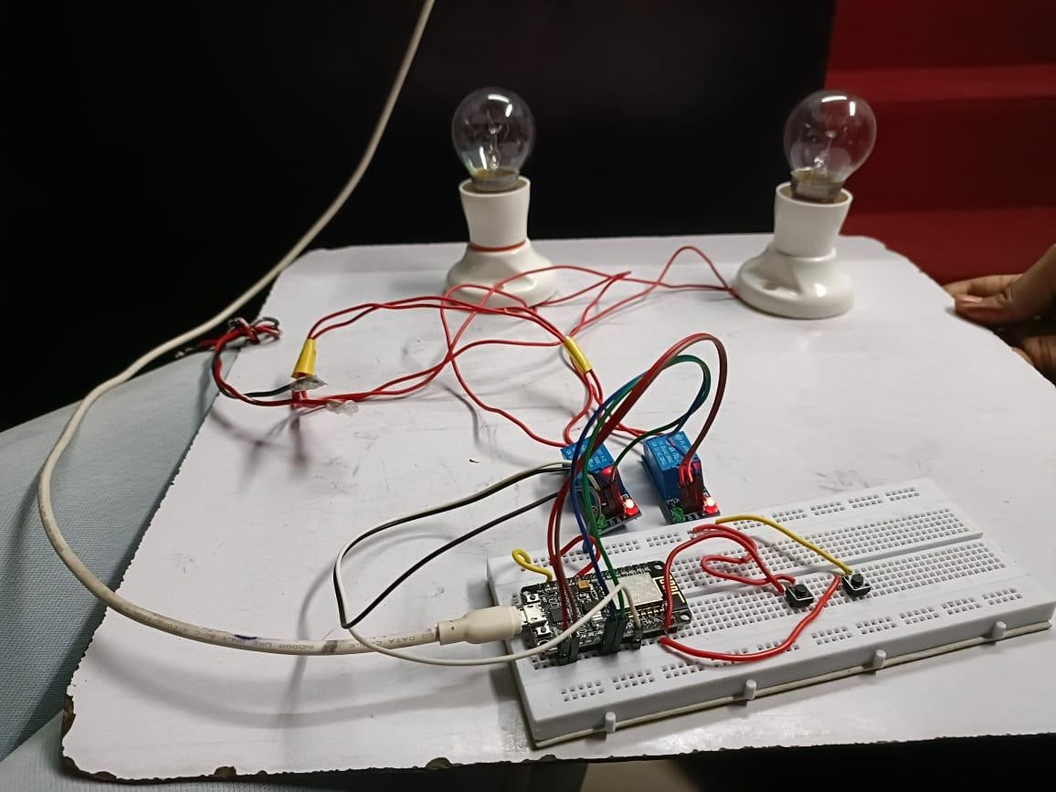

Figure 15: Circuit

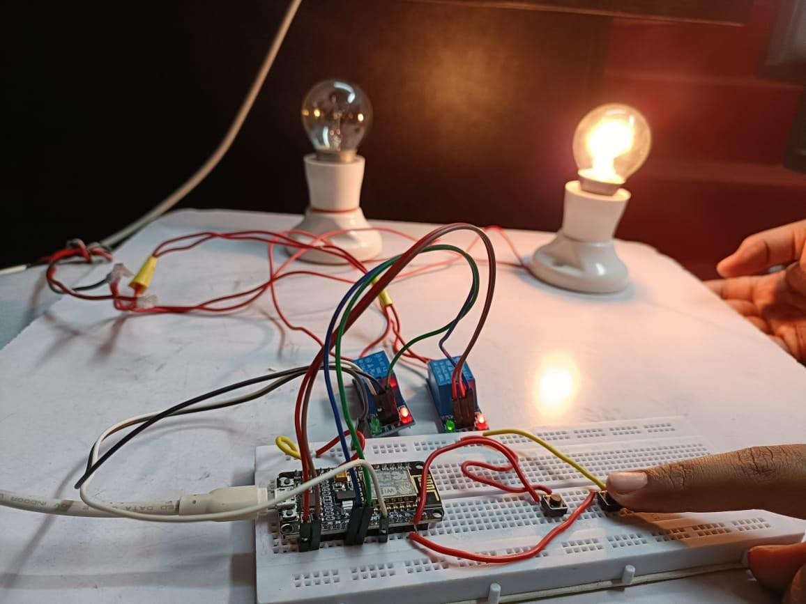

Figure 16: Circuit(Manually turning on light via switch )

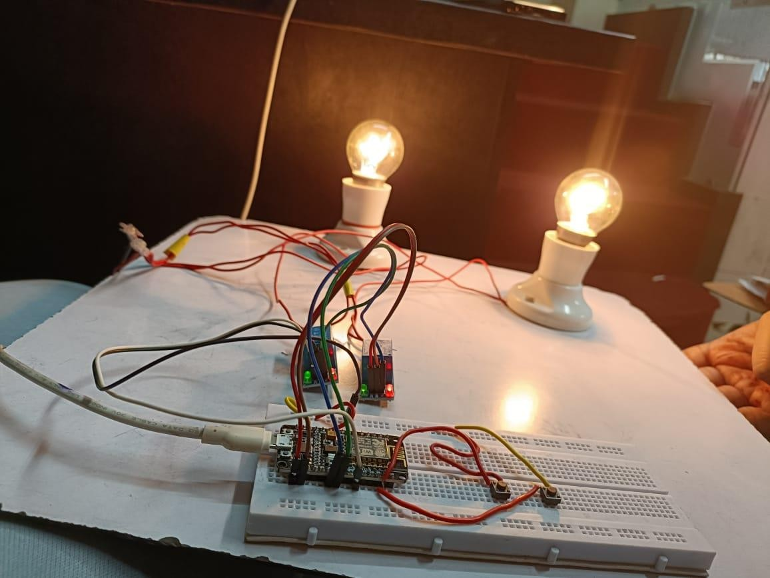

Figure 17: Circuit (Both bulb high)

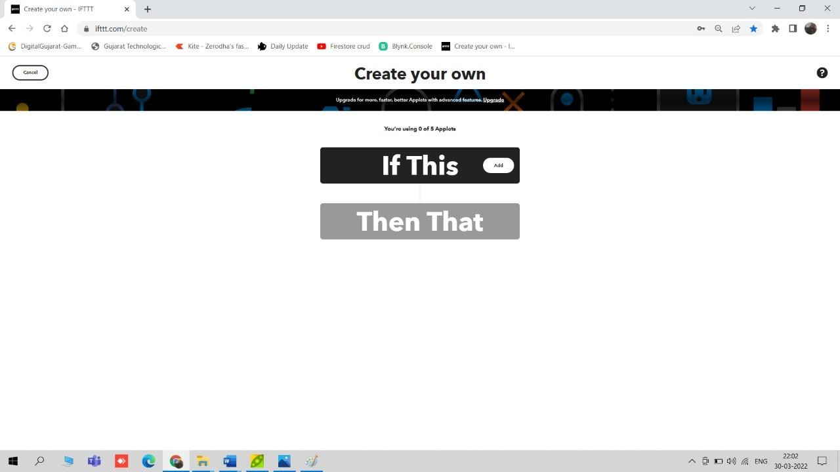

Figure 18: Creating Applet

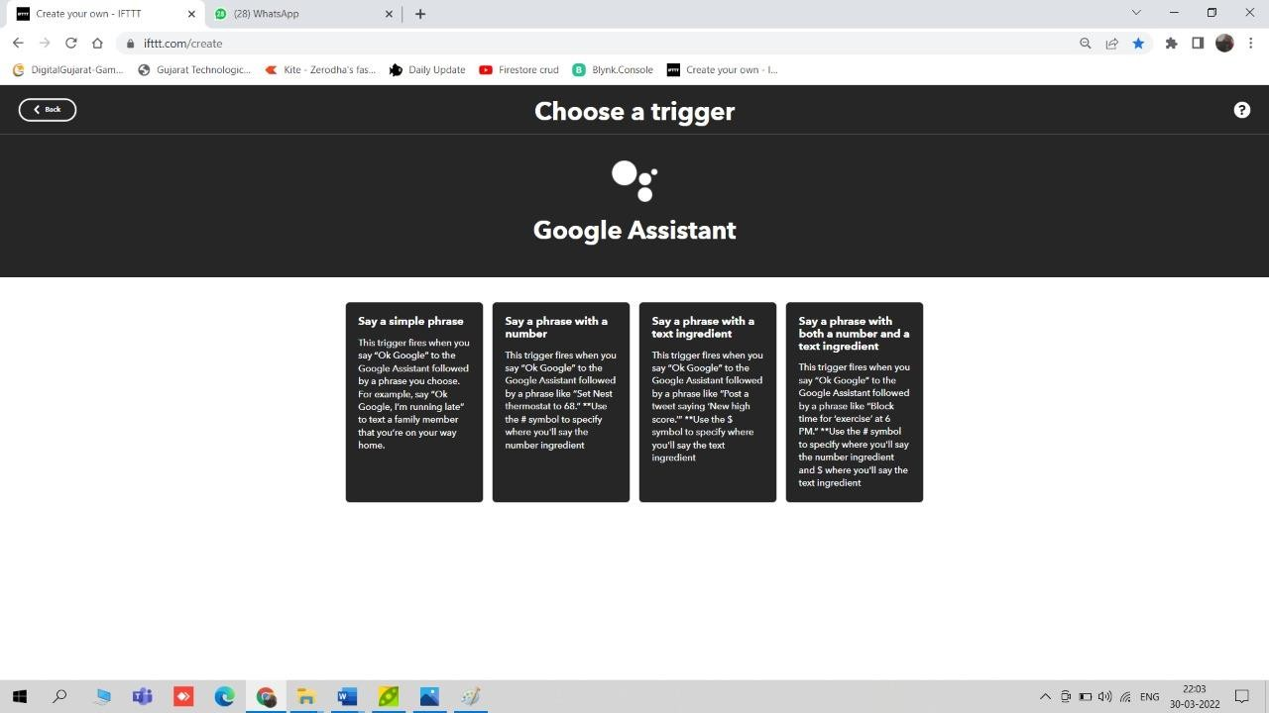

Figure 19: Creating a trigger

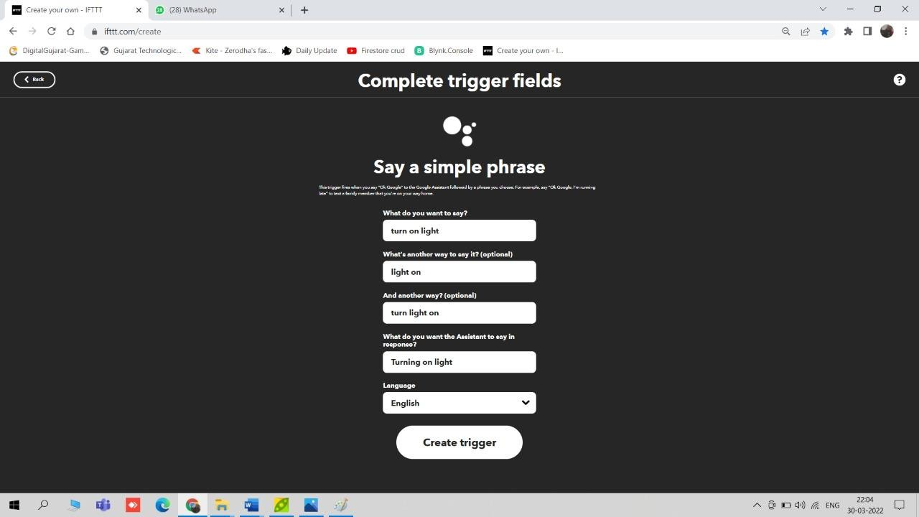

Figure 20: Creating a simple phrase to turn on light

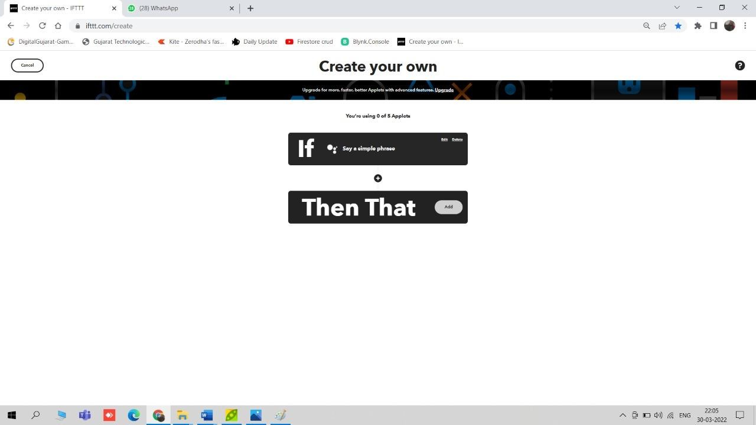

Figure 21: If this, then that

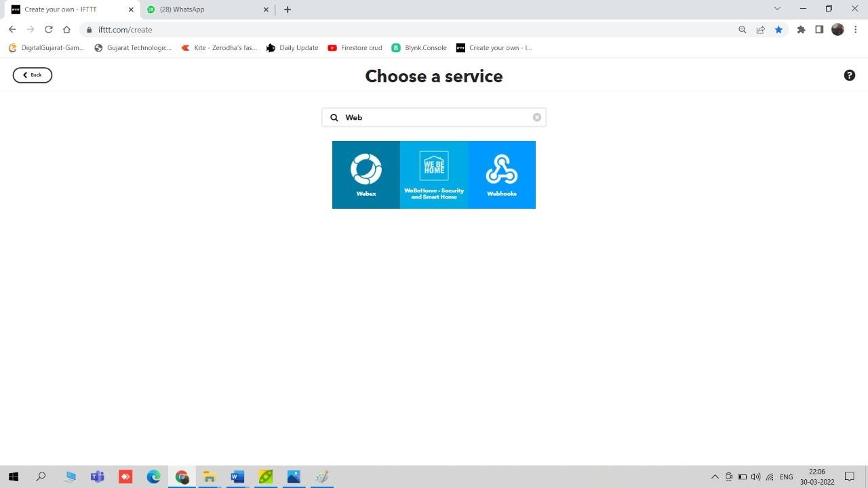

Figure 22: We need to select webhooks service to make web request

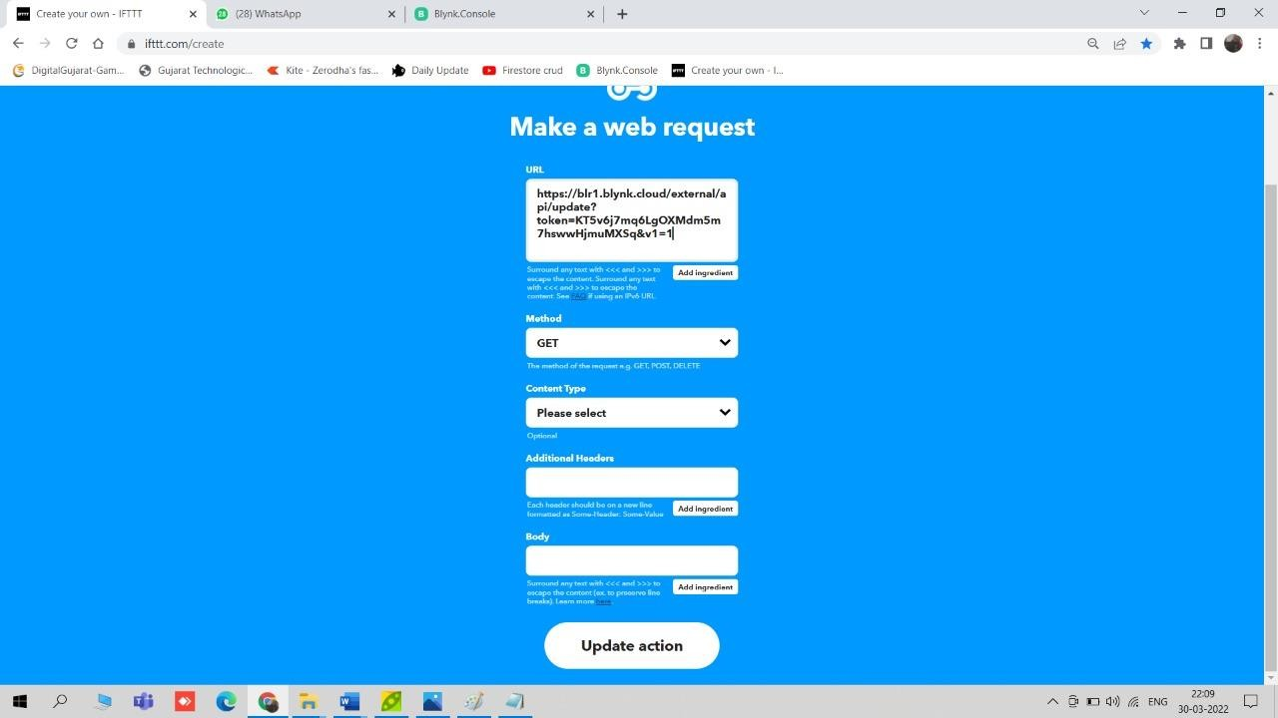

Figure 23: Creating a web request to turn on light

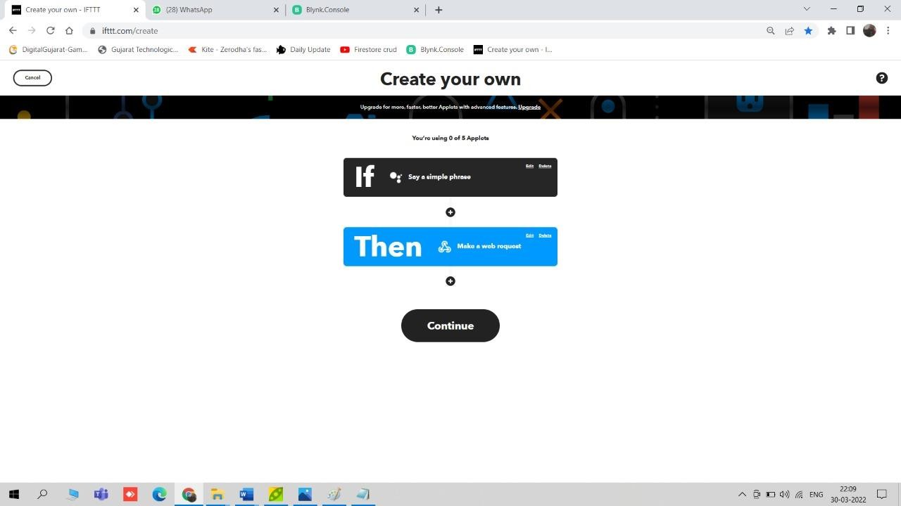

Figure 24: If this, then that

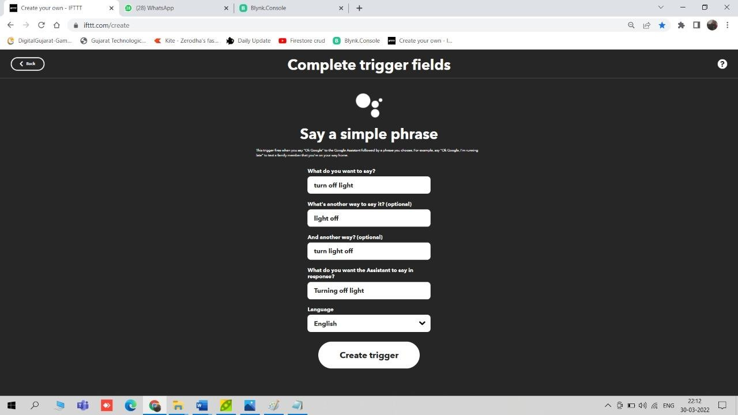

Figure 25: Creating a simple phrase to turn off light

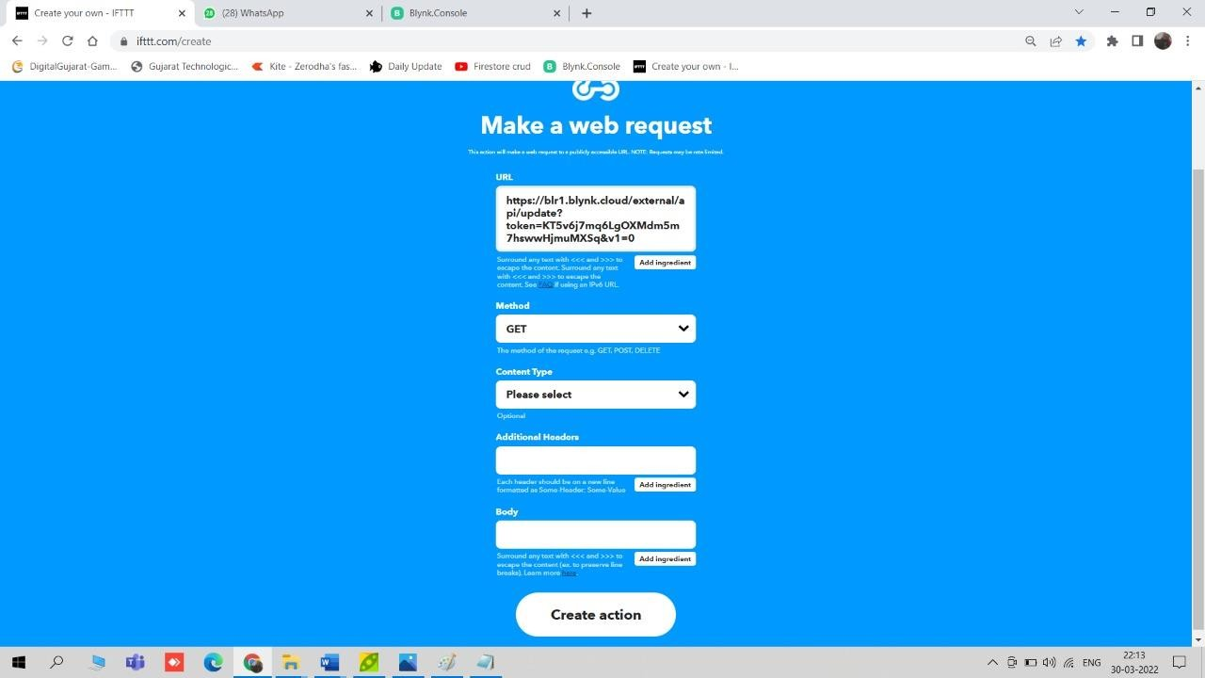

Figure 26: Creating a web request to turn off light

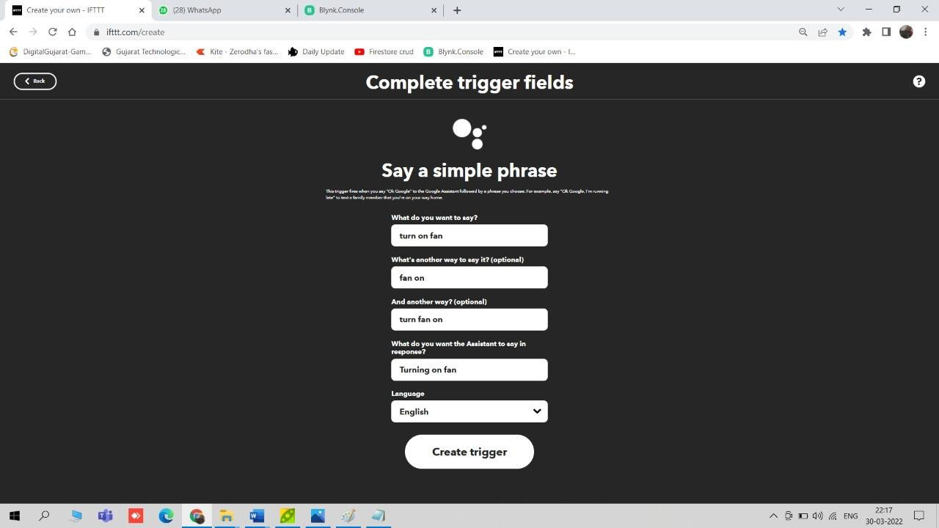

Figure 27: Creating a simple phrase to turn on fan

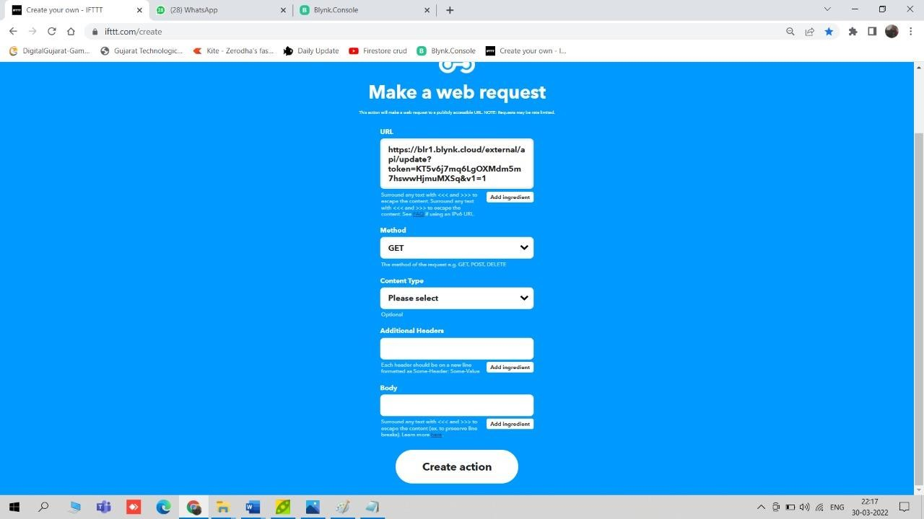

Figure 28: Creating a web request to turn on light

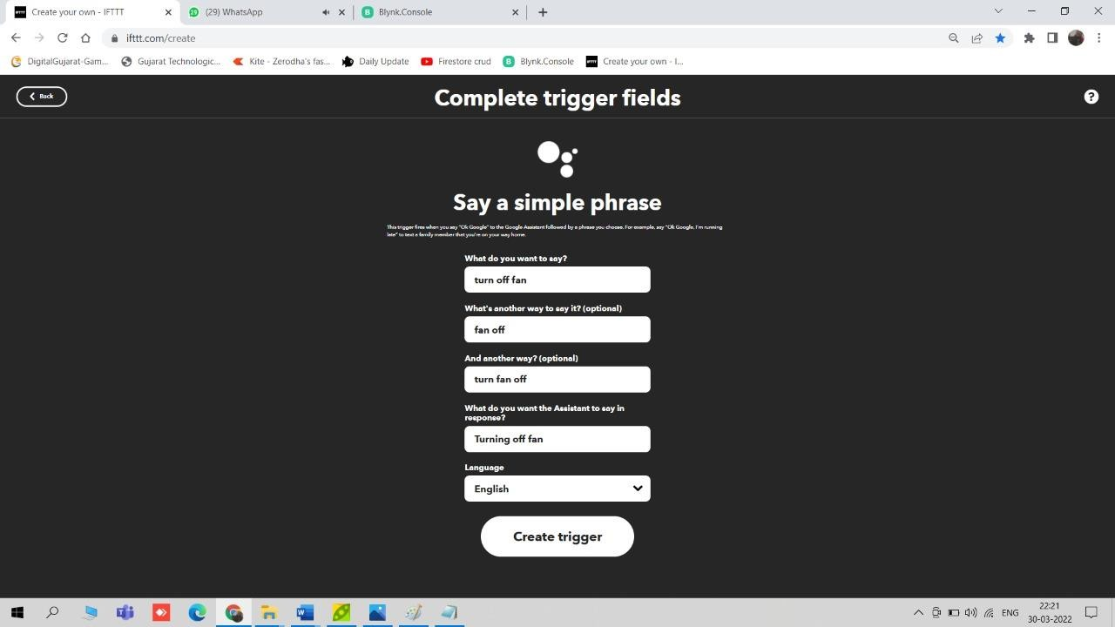

Figure 29: Creating a simple phrase to turn off fan

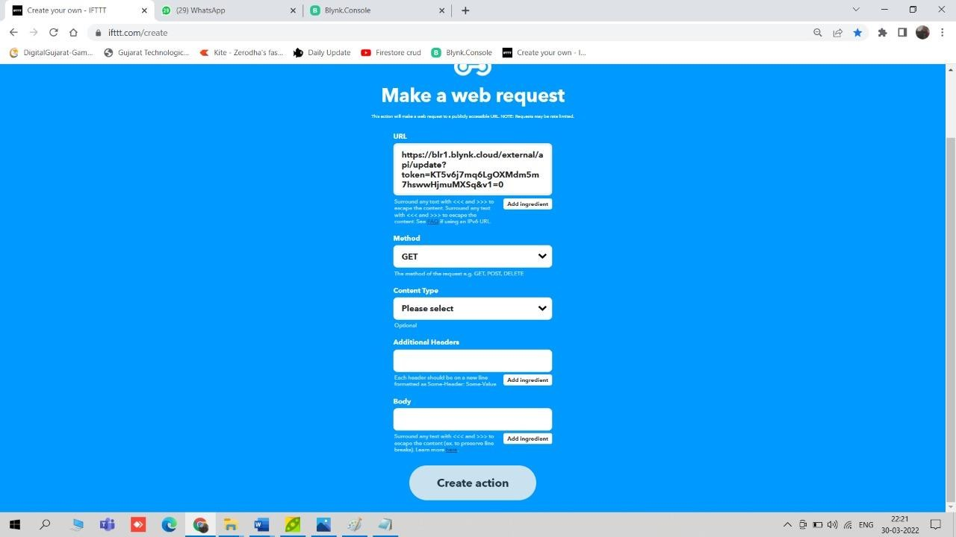

Figure 30: Creating a web request to turn off light

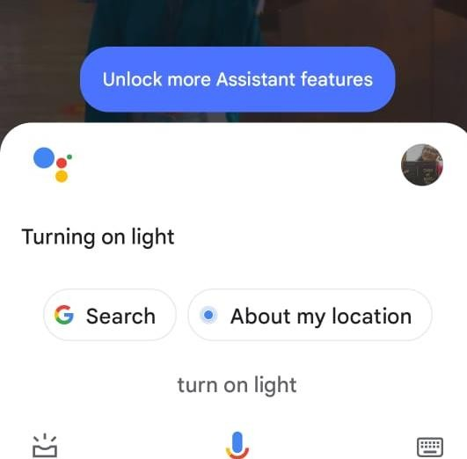

Figure 31: Google Assistant (turning on a light)

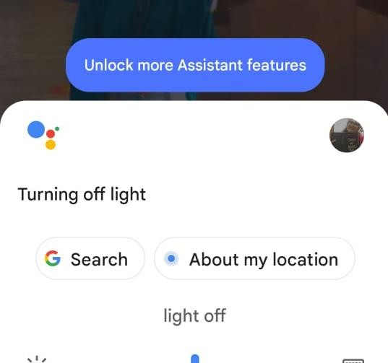

Figure 32: Google Assistant (turning off light)

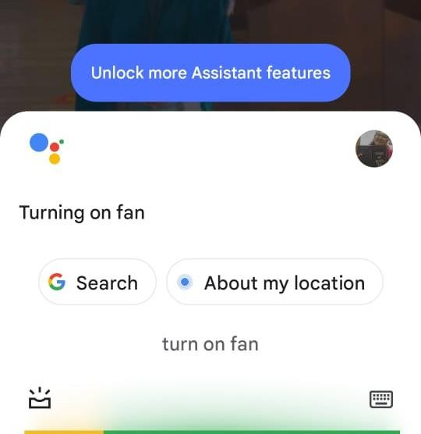

Figure 33: Google Assistant (turning on the fan)

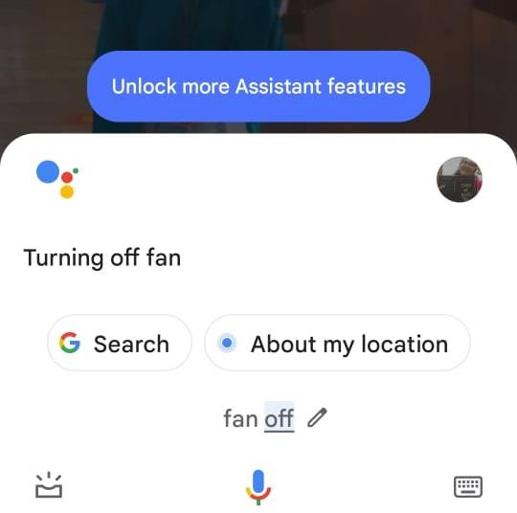

Figure 34: Google Assistant (turning off fan)

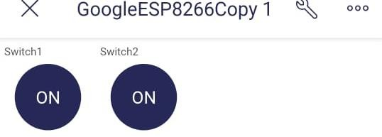

Figure 35: Light ON via Blynk IoT application

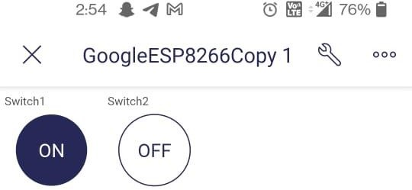

Figure 36: Light ON/OFF via Blynk IoT application

Chapter 9: Conclusion and Future work

Conclusion

The system as the name indicates, ‘Home automation makes the system more flexible and provides an attractive user interface compared to other home automation systems. In this system, we integrate mobile devices into home automation systems. A novel architecture for a home automation system is proposed using relatively new communication technologies. The system consists of mainly three components is a Bluetooth/Wi-Fi module, Arduino UNO, and relay circuits. Bluetooth/Wi-Fi module is used as the communication channel between android phone and the Arduino UNO. We hide the complexity of the notions involved in the home automation system by including them into a simple, but comprehensive set of related concepts. This simplification is needed to fit as much of the functionality on the limited space offered by a mobile device’s display. Wi-Fi/Bluetooth technology capable solution has proved to be controlled remotely, cost-effective compared to the previously existing system. Hence, we can conclude that the required goals and objectives of the home automation system have been achieved. The system design and architecture were discussed, and the prototype presents the basic level of home appliance control and remote monitoring has been implemented. Finally, the proposed system is better from the scalability and flexibility point of view than the commercially available home automation system.

Future Work

Using this system, the system can be expanded to include various other options for home security features like capturing the photo of a person moving around the house and storing it in the cloud. This will reduce the data storage than using the CCTV camera which will record all the time and store. The system can be expanded for energy monitoring or weather stations. This kind of system with respective changes can be implemented in hospitals for disabled people or in industries where human invasion is dangerous and also for environmental monitoring. Limitation to control only several devices can be removed by extending automation of all other home appliances. It will be flexible to support various wired as well as wireless technologies like Bluetooth, Zigbee, WIFI, World Wide Web. Doing this system will increase system mobility, configurable, and scalability.

